[Home](https://www.deeperblue.com/) [Freediving](https://www.deeperblue.com/category/freediving/) Guide To Freediving Safety Lanyards

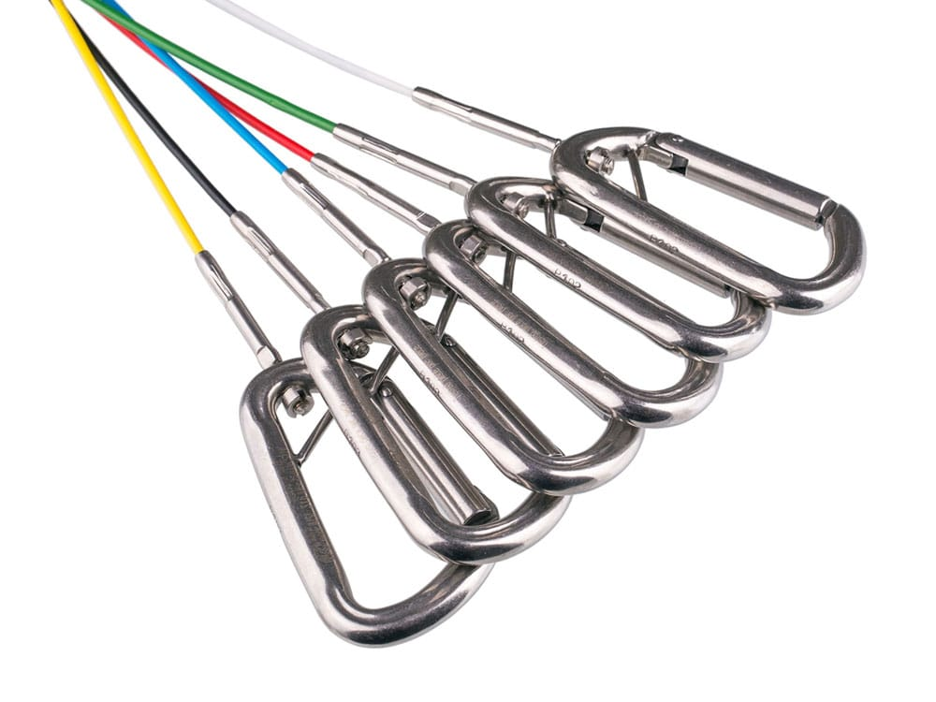

* [Freediving](https://www.deeperblue.com/category/freediving/) <https://www.deeperblue.com/guide-to-freediving-safety-lanyards/?utm_source=DeeperBlue.com+-+Newsletter&utm_campaign=c40cf3a6ee-RSS_EMAIL_CAMPAIGN&utm_medium=email&utm_term=0_29f767d265-c40cf3a6ee-222968497&mc_cid=c40cf3a6ee&mc_eid=9fbbde570f>

Guide To Freediving Safety Lanyards

By **[Kristina Zvaritch](https://www.deeperblue.com/author/kristina-zvaritch/)** -

August 8, 2018

* [Facebook](https://www.facebook.com/sharer/sharer.php?u=https://www.deeperblue.com/guide-to-freediving-safety-lanyards/&t=Guide+To+Freediving+Safety+Lanyards) Twitter Pinterest [LinkedIn](https://www.linkedin.com/shareArticle?mini=true&ro=true&trk=EasySocialShareButtons&title=Guide+To+Freediving+Safety+Lanyards&url=https://www.deeperblue.com/guide-to-freediving-safety-lanyards/) Email

In our article about [lanyards for freediving](https://www.deeperblue.com/the-importance-of-lanyards-for-freediving/), we discussed the importance of lanyards as a safety tool in-depth training sessions. If you are diving with a nose clip, have bad visibility, or a strong current, a lanyard is essential. Even if you have perfect conditions and dive with a mask, a lanyard can assist in pulling up blacked out divers and keeping them close to the line rather than drifting away into the blue, so they should always be considered a necessary piece of equipment when training depth. But how do you decide which lanyard is right for you and where you place it on your body?

What to look for in a lanyard

There are resources online to make your own lanyard, but unless you are an expert and have access to quality materials, it is a better (and safer) idea to buy one from a company that sells tried and tested, reliable lanyards. Some features to look for in a lanyard include:

* A quick-release system that only requires one hand, usually either a colored tab attached the velcro strap on a wrist or ankle or a snap release that will free the lanyard and carabiner but will leave the strap still attached to you.
* A cord that is sheathed in plastic (cords with no plastic can become kinked over time if not stored properly and also develop weak spots that will eventually fray).
* An extra D-ring on the wrist, ankle, or belt attachment.
* Swivel at one or both ends of the lanyard.
* Aluminum, stainless steel, or carbon fiber carabiner that is big enough to move freely on the rope and can be opened.

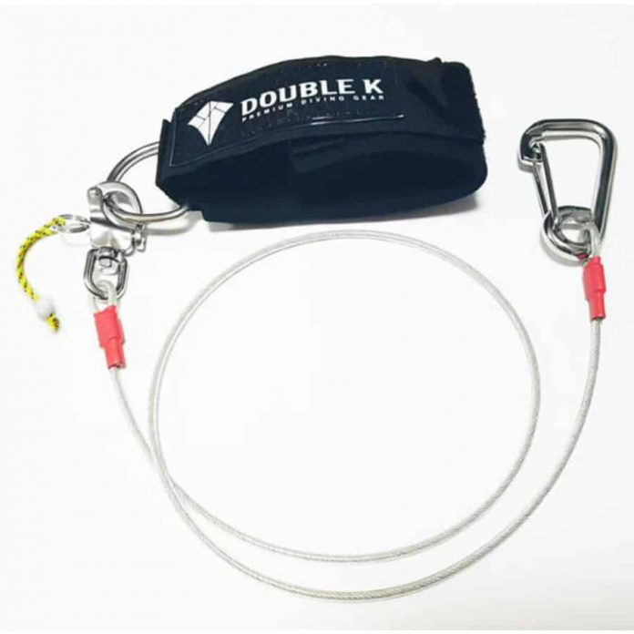

*Double K freediving lanyard with snap release*

If you buy a lanyard from a reputable company, they will most likely have all of these features as they are designed specifically for freediving and are usually up to official competition safety standards. Make sure to test a lanyard before trying it out in open water by stepping on one end and giving the other end a strong tug, or by looping both ends around a bar and hang from them with your full weight.

Where to wear your lanyard

Lanyards do not always have to be on the wrist; in fact, that could hinder you in FIM (free immersion) and CNF (constant weight no-fins), but works well for CWT (constant weight). So where is the best place to wear your lanyard for each discipline?

Constant Weight (CWT)

Wrist placement of a lanyard is ideal for CWT, as your legs are in constant movement but your arms remain more or less still. There is less chance of the lanyard getting tangled, and a stainless steel carabiner is more ideal as it is heavier than aluminum or carbon fiber and will stay in front or ahead of you during a dive. It is also better to wear it on the wrist for safety; if you have to get pulled up on the line or if you are diving with a counter ballast system, you will be more streamlined on the way up, thereby making rescue that much quicker.

Free Immersion (FIM)

Since the arms are in constant movement but the legs remain more or less still, lanyard placement on the ankle is ideal (if you are training without fins). You can still place the lanyard on your wrist (especially if you are training with fins on), but as you get more experienced and take the fins off, you will find that placing the lanyard on your ankle will leave your arms free to pull and will have less chance of entanglement. For FIM, an aluminum or carbon fiber carabiner is ideal so that it will stay behind you and not bounce against your hand on every pull.

Constant Weight No-Fins (CNF)

CNF is a little more complicated. If you have a 1m lanyard, you can place it on your ankle or wrist, but this may cause entanglement. It is more common in competitions to see athletes wear the lanyard on their waist for CNF, and there are positives and negatives to this. It is more comfortable and less likely you will get entangled, but if you are getting rescued by being pulled up or with a counter ballast system, the placement of the lanyard will cause you to be pulled up horizontally, which can injure your back and also create a lot of drag, slowing down the rescue process. Fortunately, CNF dives are usually much shallower than CWT or FIM, but you will have to weigh the advantages and disadvantages for yourself.

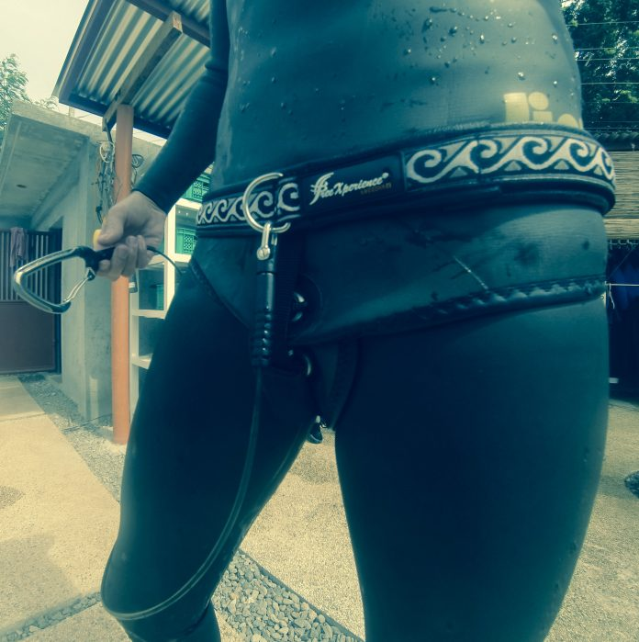

*FreeXperience Evolution II belt freediving lanyard*

It is important to note that the lanyard should be attached to a separate belt and not your weight belt. Since your weight belt is flexible, getting rescued by getting pulled up or with a counter ballast can be dangerous. Also, in an emergency, if you have to drop your weight belt and your lanyard is attached to it, it presents even more of a safety hazard to have lost the lanyard. There are special belts designed for CNF to attach to your lanyard that is worn above your weight belt, just make sure they are able to be closed securely and have a quick release system in place. Lanyards with stainless steel carabiners can be considered more ideal for CNF dives.

Final Thoughts

Lanyards are an important safety tool for freedivers at all levels, but especially for deep divers, or diving with buddies that do not go as deep as you. A safety lanyard should be one of your first equipment purchases when you are training depth or should be rented if you only train occasionally and do not have your own equipment. Again, even though you can find do-it-yourself guides on how to make a lanyard on YouTube, that does not mean you should try to save money and make one yourself. Do not settle for cheap equipment or buy from unreliable sources. A lanyard can be the difference between life and death in a rescue situation, so treat it that way.