http://divewise.org/education/freediver-recovery-vest-2/

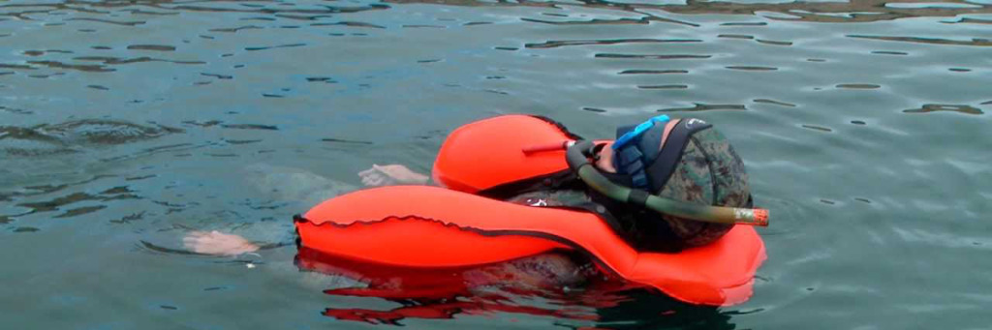

[HOME](http://divewise.org/) » [EDUCATION](http://divewise.org/education/) » FREEDIVER RECOVERY VEST

**FREEDIVER RECOVERY VEST**

The **[Freediver Recovery Vest (FRV)](http://divewise.org/glossary/freediver-recovery-vest/)**allows a diver to minimize risk of [shallow water blackout](http://divewise.org/glossary/shallow-water-blackout/) by programming a max time and depth for a single dive. If exceeded, the vest will inflate and deliver the diver face-first to the surface.

**[CONTACT US TO ORDER AND DIVEWISE RECEIVES $50!](http://divewise.org/contact-us/)**

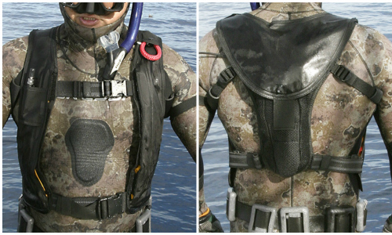

**The latest, most streamlined FRV version to date is available now – the FRV Mark II-S!**

Designed by Terry Maas of Oceanic Safety Systems, the current design is the FRV Mark II-S which is capable of depths up to 300-feet (100m). It is the most streamlined version to date, with just two straps. It rides above the weight belt and creates no bubbles upon entry. The FRV Mark II-S is configured to protect the diver using four methods including: Depth Limit, Time Limit, Failure to Respond at Surface and Early Sink Out. It can be configured so the user must acknowledge they are conscious after 15 seconds at the surface.

vaScript.</div></div>

FRV Key Features:

* Approved by the Travel Safety Administration (TSA) for air travel for carry-on or checked luggage.
* Streamlined – users forget it’s there
* Easy, intuitive settings just like an alarm clock
* Four (4) methods to trigger inflation (Protection underwater – depth limit and time limit) (Protection at the surface – failure to respond and early sink out).
* Serves as a backup float if lost at sea
* Can be packed for service in minutes.
* Includes arm band with remote light and button to inform user. The button can be used to trigger inflation.

Freediver Recovery Vest Specs:

* Weighs 5 lbs
* Max operating depth –300-ft (100m)
* Battery rechargeable life – Thirty 8 hour days
* Remote switch for communication, activiation
* Chassis – high impact plastic and aluminum
* Units – seconds and meters
* Low battery warning
* **[User Manual](http://www.oceanicss.com/manuals/FRV_Mark_II.pdf)**

Here Juan Palma tests the Freediver Recovery Vest prototype on a Diving for a Cause trip to New Zealand. At the end he demonstrates his [spearfishing](http://divewise.org/glossary/spearfishing/) skills.

**Oceanic Safety Systems has generously offered to donate $50 for every Freediver Recovery Vest that is purchased through DiveWise. Please [CONTACT JULIE](http://divewise.org/contact-us/)  to order and thank you for your support!**

**GET SAFE AND GIVE BACK**

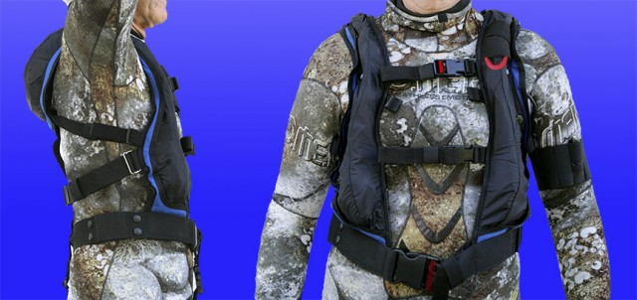 The **Freediving Recovery Vest (FRV)** allows a diver to minimize risk of shallow water blackout by programming a max time and depth for a single dive. If exceeded, the vest will inflate and deliver the diver face-first to the surface. DiveWise receives a generous $50 donation each time a FRV is purchased through our site. Please send us a note to order, thanks!

**[CONTACT US](http://divewise.org/contact-us/)**