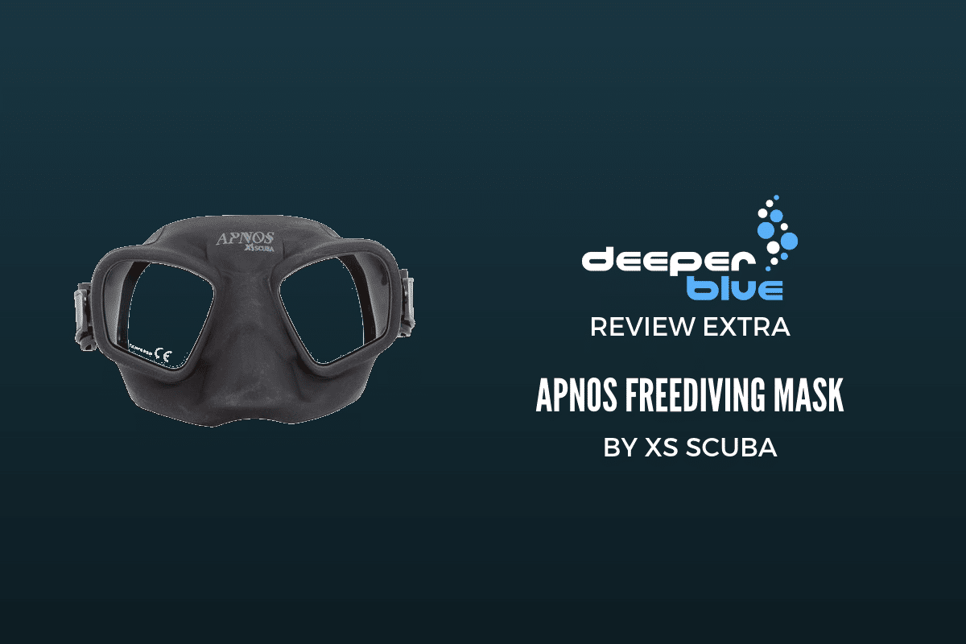

* [Freediving](https://www.deeperblue.com/category/freediving/)

Review: XS Scuba Apnos Freediving Mask

By **[Christopher Morey](https://www.deeperblue.com/author/christopher-morey/)** -

March 19, 2019

[Facebook](https://www.facebook.com/sharer.php?u=https%3A%2F%2Fwww.deeperblue.com%2Freview-xs-scuba-apnos-freediving-mask%2F) [Twitter](https://twitter.com/intent/tweet?text=Review%3A+XS+Scuba+Apnos+Freediving+Mask&url=https%3A%2F%2Fwww.deeperblue.com%2Freview-xs-scuba-apnos-freediving-mask%2F&via=deeperblue) [Pinterest](https://pinterest.com/pin/create/button/?url=https://www.deeperblue.com/review-xs-scuba-apnos-freediving-mask/&media=https://www.deeperblue.com/wp-content/uploads/2019/02/Review-Extra_-XS-Scuba-Apnos-Freediving-Mask.png&description=Review%3A+XS+Scuba+Apnos+Freediving+Mask) [Linkedin](https://www.linkedin.com/shareArticle?mini=true&url=https://www.deeperblue.com/review-xs-scuba-apnos-freediving-mask/&title=Review%3A+XS+Scuba+Apnos+Freediving+Mask) [Email](mailto:?subject=Review:%20XS%20Scuba%20Apnos%20Freediving%20Mask&body=https://www.deeperblue.com/review-xs-scuba-apnos-freediving-mask/)

I’d just completed my First-Aid/O2/AED certification and was on my way out of the local scuba shop when the owner/instructor stopped me.

*“Hey Chris, I found this cool freediving mask made by XS Scuba and I ordered one. Hang on while I go get it…”*

The owner, Bob, has every scuba and instructor cert known to man, but he’s new to freediving. *“Some scuba company is trying to make a freediving mask,”* I thought. *“How quaint”*… although I prepared to be supportive.

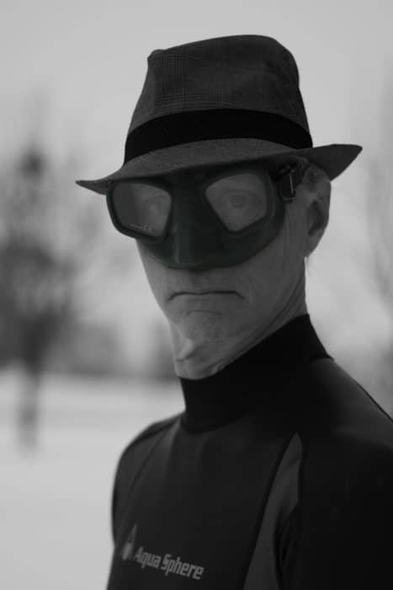

The XS Scuba Apnos Mask

He handed me the mask… I felt a tick developing under my left eye… A rivulet of sweat ran down my temple… I hoped they wouldn’t notice the slight tremor as I reached for it…

One day, not long ago, I awoke to the realization that I had a problem. A mask problem. I had a disturbing number of masks. Granted, seven of them were [Aqua Lung Spheras](https://www.deeperblue.com/review-extra-aqualung-sphera-freediving-mask/) (and who doesn’t have seven Spheras….right?), but still; I had to stop buying masks.

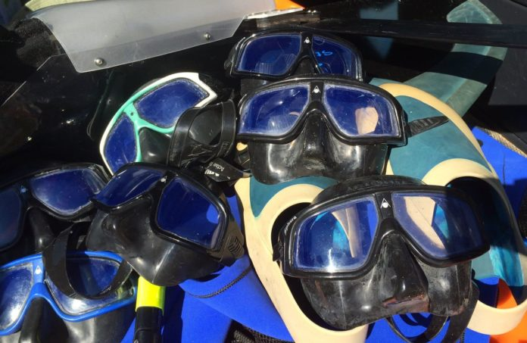

Seven (7) Spheras

Enter the XS Scuba Apnos

It looked cool… I tried it on. It felt better than no mask at all. With feigned nonchalance, I reluctantly handed it back. *“Nice”* I managed to croak, my throat suddenly thick and parched. I turned and fled the store.

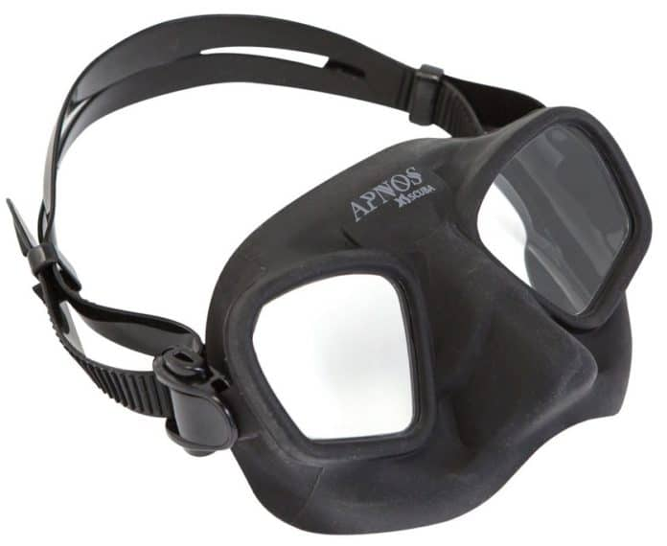

The XS Scuba Apnos Freediving Mask

First Impressions

The Apnos is quite small – with less width but a tad more depth than the Micromask. The skirt is very soft and has a nice flat exterior finish. The lens frame is molded into the mask body as are the attachment points for the strap.

I noticed immediately that the rigid cross-piece holding the lenses in one plane runs down and across the bridge of the very-generous nose-pocket, instead of between the eyebrows. This seems intended to mitigate the frame exerting pressure on the brow-ridge – a common problem with very low volume masks. In dry tests, the mask glommed onto my face comfortably and maintained a robust seal with very little suction. When I inhaled forcefully and pressed the mask into my face to simulate compression at depth, the Apnos’ flexible skirt easily accommodated the reduced volume and the mask remained comfortable.

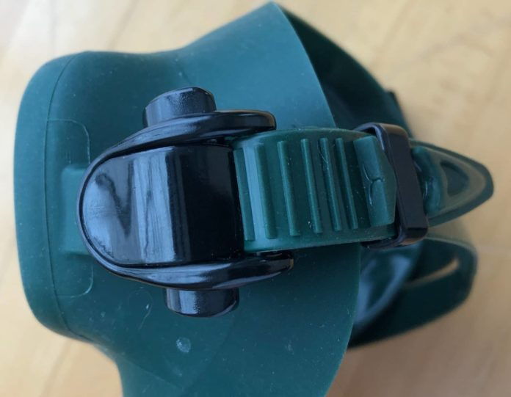

The Apnos Flexible Skirt

The Apnos’ low-profile and volume come at a slight cost in the visual field relative to the Micromask. It does not feel claustrophobic but is noticeable switching between them.

The buckles are worth a mention. A pair of large pinch-buttons make strap adjustment very easy – even with the mask in place.

In The Water

I compared the *Apnos* with the Aqua Sphere Sphera, Technisub MicroMask, and my ancient Cressi Matrix – which has reduced volume and a phenomenal field of vision due to thick prescription lenses bonded to the interior.

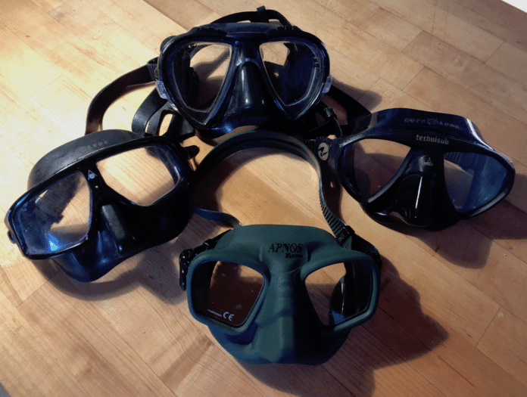

The comparison test masks

These are all masks I like and use regularly. Together they set the bar for freediving mask performance as follows:

* **Matrix:** Overall Field of View
* **Sphera:** Comfort and Compressibility
* **Micromask:** Volume and FoV

Observations

*Visual Field:* Many low volume masks give an immediate impression of tunnel vision, the *Apnos* is not one of them. It gives up some to the Micromask, but the view is generous and improves with compression.

*Comfort and Fit:* The Apnos soft skirt makes for a comfortable and durable seal.  It compresses readily and does not put painful pressure on the brow-ridge with delayed equalization.

*Volume:* Volume tests yielded interesting results. Heres the list – from most to least (uncompressed). Keep in mind these are imprecise measurements based on an average of three tests with each – your results may vary:

* Sphera >=115ml
* Matrix  >=95ml!! (with thick script lenses)
* Apnos >=85ml
* Micro >=75ml

As you can see, low volume is a bit of a golden calf. Due to its compressibility the Sphera – which has the largest volume – is the one that will go deepest without equalizing.

The Apnos has a greater volume than the Micromask but balances this with a softer, more compressible, skirt. (Now that we have Hektometer goggles, which rely on a very soft, thin silicone membrane to self-equalize, it will be interesting to see how masks evolve.)

Features

* Freediving specific mask
* Low volume design
* Internal stiffener keeps lenses true
* Dual lens, Tempered glass
* Wide split style silicone strap

Price

* $80 USD / €59 EUR