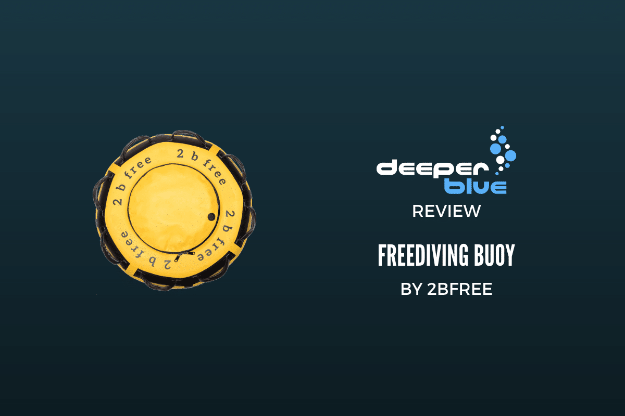

My first buoy was one of them inflatable neck-pillows – diving in a lake in Holland we figured we only needed a rope to be somewhat straight to give an indication of which direction was down. Visibility was a meter and the buoy wasn’t used to breathe up on or store the line in -all it did was hold the rope up. It was all a bit more primitive then. Free immersion? Well, you could pull the pillow down and then giggle as it expanded in your hands while you were swimming it up.

Then came those cloth buoys with the car tire inside – remember those? With zippers the size of train tracks, which would get salted/rusted shut or open, but never in a position where you’d want them, and ripped from the cloth every time you sneezed during a breath-up. Some of them didn’t have holes in the bottom to let the water out and they were a gym session to get out of the water, hoisting them on land and then balancing them sideways to get the water out. Good for a work-out, but crap as a piece of equipment.

People soon caught on that there was a bit of a market for these things; I remember Neptune started making them, and Apneaman buoys were quite good, but it was still the canvas bag meets inner tube type deal, with rusty zippers and prolonged work-outs. Then Alexander Bubenchikov did something that really was quite innovative -he made a buoy that was actually good and easy.

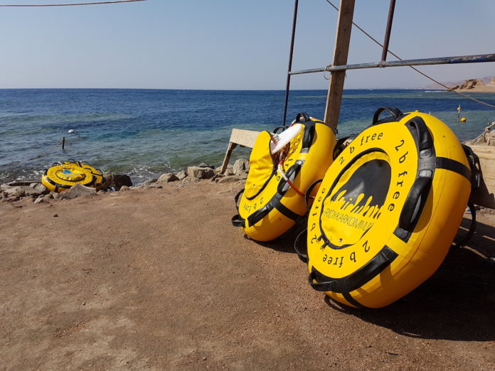

2bfree Freediving Buoy

Of course by this point he’s mostly known as a gold medal winner, and before that as the man who won bronze with a world record dive (true story), but he’s also the man behind [2bfree freediving equipment](https://2bfreeequipment.com/), a company that started out making the sleekest lanyard in freediving, and now also makes buoys. But not just the canvas bag inner tube contraption -no, Boobie (as I call him, because my mind is that of an 8-year-old and I haven’t found ways to hide it) did something very clever: he integrated the tube into the buoy itself, put it all in a durable material, found zippers that don’t rust, and made the bottom out of mesh.

Suddenly we had a buoy that you could just walk in and out of the sea with! No more tipping or waiting for the damn thing to drain like the bladder of a camel with kidney stones. But there were more advantages: the tube was quite big, so it holds quite a bit of air (very handy for free immersion, but also quite a bit of rope (we’ve fit in more than 100 meters of thick, 12 mm rope). So no more spilling rope out of the canvas bag that doesn’t shut. And Boobie is a freediver himself, so he knows that you need something inside the buoy to attach the line to -done! D-rings on the outside as well? Of course! 4 of them. D-ring underneath, for the carabiner? Naturally. And then also something you didn’t know would be nice but is almost indispensable soon as you try it: handles both on top and below the buoy. It’s a breathing up thing: if you sit on your noodle while breathing, it’s nicer to grab the top handle, if you are laying down on the water, it’s more relaxed to grab a lower one. The top ones are nice for when you are talking to students, too.

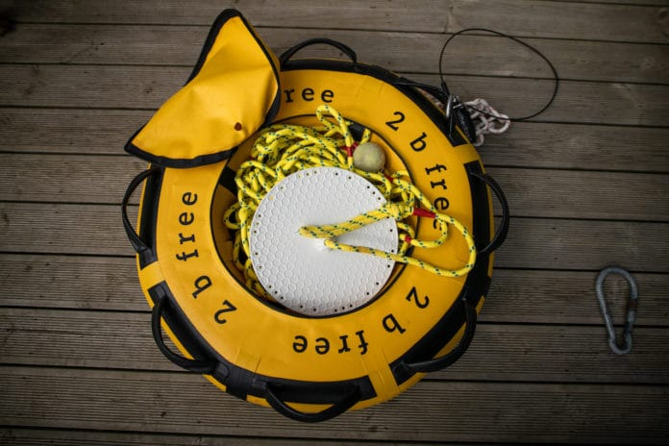

>

2bfree Freediving Buoy

Talking about students, the buoys seem to have been designed for schools. Not only are they made to attach several of them in a row, but they also seem to last quite well. We use them in real life conditions in the Atlantic several times every week, and they’ve managed to last for 2 years already. So when a new edition came out we were quite eager to test them.

Luckily, all that was good about the first generation remains. What’s different is a new underside – still as effective at draining, but now from the same PVC type material as the rest of the buoy. In our old ones, the mesh was beginning to tear, so it’ll be interesting to see if this new way is an improvement. Another thing that’s changed is the way the D-rings are attached: it seems more sturdy now, more part of the whole rather than taped on -though we never had a problem with the old ones in that respect. The last change is that it now comes with a little dive flag and a holder for a said flag. I guess it’s for visibility, but I’ve never used it – if a skipper can’t see a big yellow pizza in the water, he’s not going to see the little slice of pepperoni on to of it either.

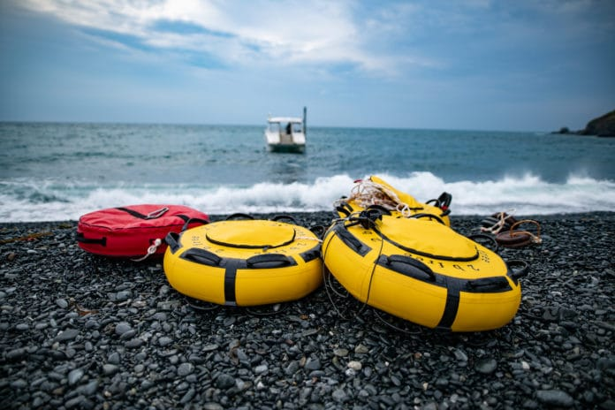

>

2bfree Freediving Buoy

We’ve dived on this buoy and its predecessors all summer, and can wholeheartedly recommend them. Everything is well thought out, and it’s built to survive rough conditions and repeated use. Some of the hard plastics broke under strain, but the d-rings are solid. The tube seems to lose a bit of pressure over time, but it comes with a foot pump and topping it up every week is not a big issue. We’re very impressed with how steady it is, how well it holds 4 people, all their stuff and a whole lot of rope, but what I still enjoy most is how you can just walk it out of the sea without fuss. Every time it does that I think to myself “Yeah buoy!”

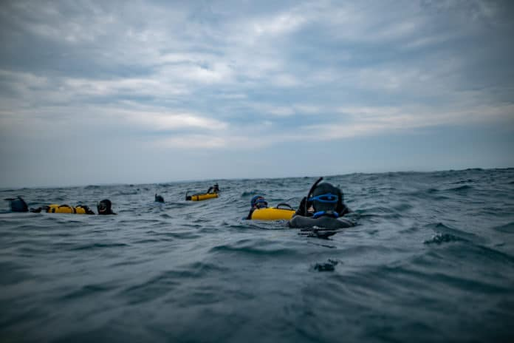

>

2bfree Freediving Buoy

Key Features

* PVC outer and inner material
* Incorporated PVC inner tube
* Size – 73 cm
* 4 d-rings
* 2 other attachment spots
* 16 handles
* rust-proof zipper

Price

RRP – 2bfree Freediving Buoy – €180 euro (~$205 USD)

Buy Now

**2bfree Freediving Buoy**

Price: **€180**

