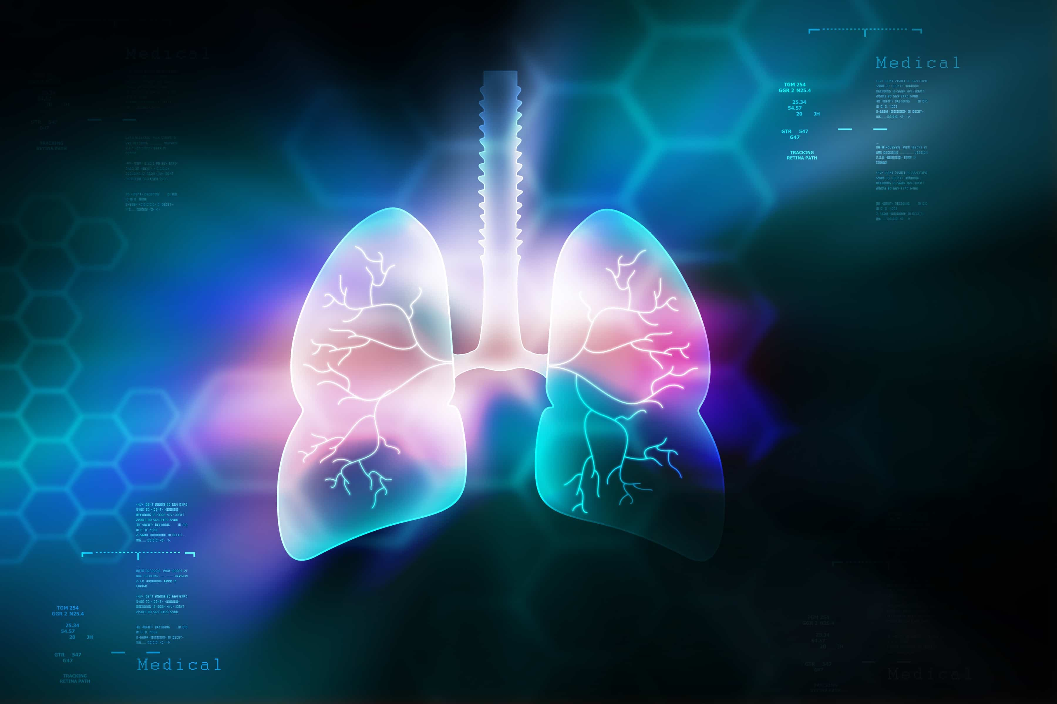

[Freediving](https://www.deeperblue.com/category/freediving/)

Risks Associated With Lung Packing In Freediving

By **[Kristina Zvaritch](https://www.deeperblue.com/author/kristina-zvaritch/)** -

May 31, 2018

Glossopharyngeal insufflation, which is popularly known as lung packing within the freediving community, is the practice of increasing the natural total lung capacity by gulping or sipping more air into already fully inflated lungs.

This can be a sensitive subject amongst freedivers and is known to stir up heated debates. There is not much scientific evidence on packing, but there have been some incidents where packing might have resulted in pulmonary barotrauma (lung squeeze), arterial gas embolism, pneumothorax (collapsed lung), and lung bleeding. This alone should make freedivers pause to further examine the risks associated with packing, and decide for themselves if these risks outweigh the benefits.

What are some of the reasons freedivers utilize lung packing?

Improve Equalization

Packing may improve equalization, but do the benefits outweigh the drawbacks? In reality, you need to work on your technique instead of using packing for deeper equalization. Go back to the basics if you have to, and focus on efficient equalization rather than a quick shortcut to get you deeper, faster. Working on your flexibility by stretching is a better approach, which can help you inhale more air naturally without the added stress of packing, while also allowing you to take your mouth fill deeper.

More Oxygen

Yes, the extra air in your lungs will provide more oxygen. But how much longer does it take you to pack? In those precious seconds that you are forcing more air in, you are using up the oxygen you already have. Let’s not forget, your buoyancy will change due to the extra air, which means you will struggle more in the first few meters to descend, which uses extra oxygen, or you will need extra weight on your belt, which will cause you to be heavier on the ascent and force you to use more oxygen on the way back up to the surface.

We are aware of how important mental and physical relaxation are to stay safe during a dive. While packing, your body tenses up moments before you submerge. Packing also raises your heart rate, which decreases your ability to conserve oxygen. There are also instances of freedivers who have blacked out before even starting their dive because they packed too much, due to too much pressure being put on the artery leading to the brain.

Possible Risks

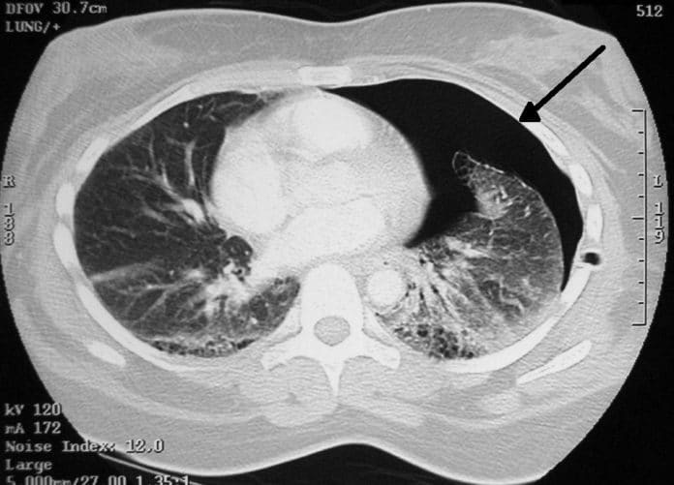

*CT scan of pneumothorax*

*• Pulmonary Barotrauma (lung squeeze)* – During the ascent, after packing, the quantity of air in the lungs does not greatly decrease. If blood remains in the lung capillaries due to blood shift, it is possible the already enlarged blood vessels in the lungs may rupture.

*• Increases risk of DCS/Narcosis*– Since the lungs carry more nitrogen from packing than from a natural inhale, packing could come with a greater risk of decompression sickness and nitrogen narcosis.

*• Arterial gas embolism*– Results from bubbles entering lung circulation, traveling through the arteries and blocking blood flow in the small vessels, thereby causing tissue damage.

*• Lung overexpansion*– After packing and upon ascent, due to blood shift, the lungs may lag behind in re-expanding back to normal size during the last few meters. This may result in lung overexpansion unless the freediver exhales towards the end of the ascent.

*• Pneumothorax*– Air leakage into the space between the lung and chest wall, which pushes on the outside of the lung, causing it to collapse.

*• Blacking out before starting the dive*– This is associated with freedivers who over-pack, which leads to reduced blood pressure and may force you to finish your dive before you even start.

What Does All Of This Mean For You?

There are freedivers who copy YouTube videos or hear what advanced freedivers do and attempt to imitate them. These freedivers are in danger of copying the wrong techniques, advancing too quickly without a proper understanding, and may risk their own safety without even being aware of it. Yes, some of the top freedivers pack before their dives, but there are also top freedivers that do not pack, yet still achieve great results. You should not feel rushed to go deep or increase distance or time quickly; instead, learning at your own pace, refining techniques, and staying safe should be your biggest priorities.

In the end, you are the master of your own fate. There are risks associated with packing, and even if you ignore the risks, the disadvantages somewhat erase the benefits. Yet if you are still set on packing, the least you can do is to learn from a professional in real life (not from a YouTube video), avoid increasing the number of packs dramatically between sessions or exercises, and do not let impatience drive you to achieve quick results rather than approaching depth, distance, or time in a safe manner.



**[Kristina Zvaritch](https://www.deeperblue.com/author/kristina-zvaritch/)**

Kristina, an AIDA Freediving Instructor, discovered her love for the sea as a PADI scuba divemaster in Dahab, Egypt, where she shared the Blue Hole with freedivers and developed a serious passion for the single-breath sport. Nowadays, when she isn’t nose-deep in a novel on the beach, Kristina trains for depth with her husband and pretends to be a mermaid when he’s not looking.