<https://www.deeperblue.com/nose-clips-in-freediving/?utm_source=DeeperBlue.com+-+Weekly+Newsletter&utm_campaign=a8c18cacf5-RSS_EMAIL_CAMPAIGN&utm_medium=email&utm_term=0_29f767d265-a8c18cacf5-222994085&mc_cid=a8c18cacf5&mc_eid=aca35129ed>

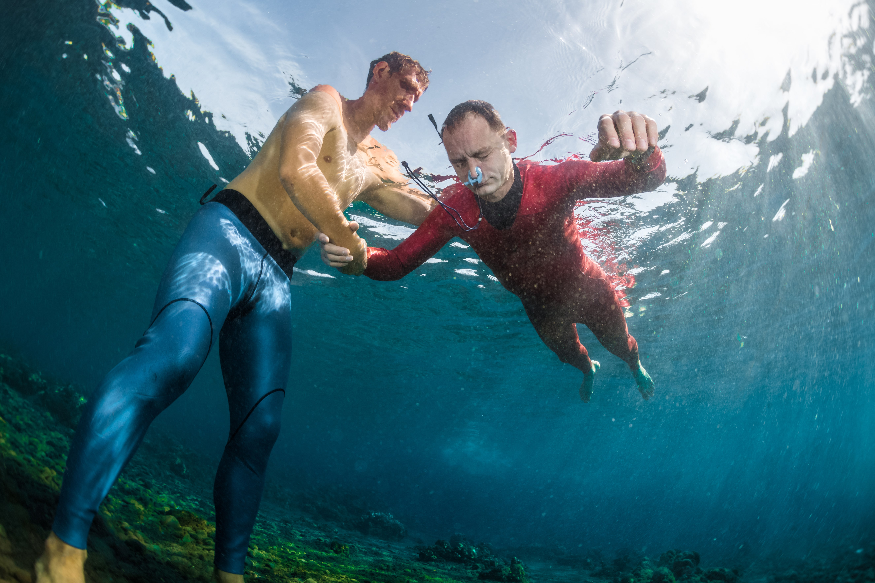

Nose Clips In Freediving

By **[Kristina Zvaritch](https://www.deeperblue.com/author/kristina-zvaritch/)** -

July 10, 2018

Whether you are watching pool or depth freediving competitions, you almost always see athletes using nose clips, either by themselves or with goggles, rather than traditional freediving masks. Why do competitive freedivers prefer nose clips? Being able to open your eyes and see where you are is comforting for beginners, especially when first exploring the ocean or training static and dynamic in a pool. But there are a few very good reasons why experienced freedivers might prefer nose clips.

Saving air you would normally use for mask equalization

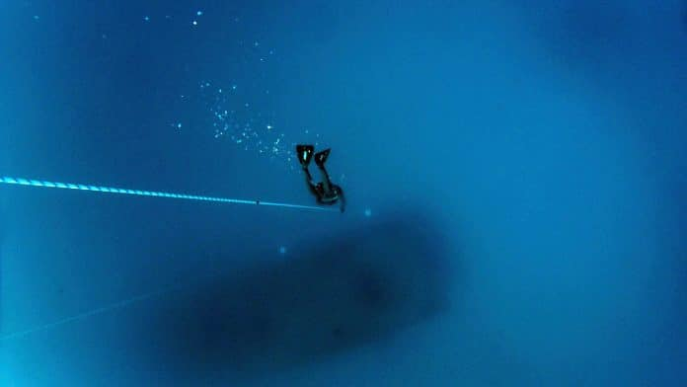

*Bubbles of escaped air from mask equalization*

Depending on the volume of your mask and how tight you wear it on your face, you have to remember to release air from your nose every once in a while to prevent mask squeeze when training depth. This precious air may not seem like a significant loss, but depending on factors such as how often you equalize the mask, the depth you are going to, and the efficiency of your mask equalization, you could be losing more air than you think! Using a nose clip instead of a mask leaves you with more oxygen and less worry about learning mask equalization techniques for depth.

Hands-free equalization

When training depth, constantly bringing your hand up to your nose to equalize can be a real nuisance. Setting a rhythm for free immersion and no-fins is essential in order to keep from slowing down too much and letting technique suffer while equalizing. It is also difficult performing constant weight with monofin and staying streamlined with one hand on your nose. Being able to equalize hands-free opens so many doors for smoother pulls and arm strokes, effortless freefalls, and a cleaner technique.

A stronger Mammalian Diving Reflex

The mammalian diving reflex (MDR) is what [enables us to stay underwater for longer, slows down our hearts, and reroutes blood to our essential organs](https://www.deeperblue.com/the-science-behind-the-freediving-breath-hold/). A splash of water on the face triggers this reflex. But the most important parts of our faces that need submersion in water are the areas around the forehead, nose, and eyes due to high receptor density in these areas. Masks cover our nose and eyes and therefore produce a less significant response than a nose clip would, since a nose clip leaves these areas, and the receptors in them, bare and exposed. Using a nose clip prompts a stronger MDR earlier, and can also help with relaxation since it encourages you to close your eyes and can make you feel more in tune with the water.

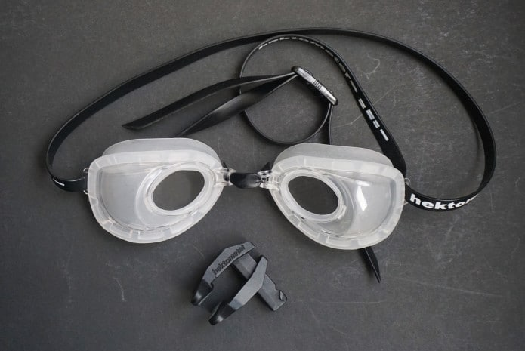

*Hektometer fluid goggles*

Diving with a nose clip does not mean you have to be completely in the dark underwater. Many freedivers who use nose clips wear goggles, whether they are special fluid goggles (filled with solution or seawater and have corrective lenses) or [the new Hektometer goggles](https://www.deeperblue.com/revolutionary-freediving-goggles-unveiled/), which have a special membrane that automatically equalizes the air inside the goggles without using fluid. Even without goggles, you have the option to open your eyes underwater, or just squinting occasionally, to keep line orientation. Diving with a nose clip takes some getting used to, but as uncomfortable as it may seem to dive without a mask, the benefits weigh heavily in the nose clip’s favor.